LOCAL PENSIONS PARTNERSHIP INVESTMENTS LIMITED
Lancashire County Pension Fund
Pension Fund Committee | 23 March 2018
Responsible Investment Report

Title of Paper | Quarterly Report on Responsible Investment (2017 Q4)
Lead Officer: | Frances Deakin  Responsible Investment Manager  Local Pensions Partnership Investments Ltd  frances.deakin@localpensionspartnership.org.uk
Appendices | Appendix A1 - LAPFF's Q4 2017 Engagement Report

- Executive Summary

This report provides members of the Pension Fund Committee of Lancashire County Pension Fund (LCPF) with a quarterly update on Responsible Investment (RI) matters.

- Introduction

The Fund's approach to RI has been articulated within an Investment Strategy Statement which confirms that the objective of RI is to decrease investor risk, improve risk-adjusted returns and assist the Fund's adherence to the UK Stewardship Code. The Fund's preferred approach to RI encompasses four main areas of activity:
- Voting Globally
- Engagement through Partnerships
- Shareholder Litigation
- Active Investing

Responsibility for the practical implementation of the Fund's approach to RI is devolved to Local Pensions Partnership Investments Ltd (LPP I) as LCPF's provider of investment management services. The report which follows provides the committee with an update on RI activity during the period 1st October to 31st December 2017 plus insight on current and emerging issues.

- Voting Globally

Through its investment in the LPP I Global Equities Fund (GEF) LCPF owns units in a pooled fund which invests in listed companies globally. Investors in the GEF delegate the control and exercise of shareholder voting to LPP I as part of arrangements which accommodate a pooled fund structure and associated ownership arrangements. This reflects that clients who hold units in the GEF are beneficial owners in common but do not directly own underlying securities.

LPP I exercise shareholder voting rights for the GEF centrally rather than delegating voting to individual asset managers. Decisions are taken in line with the collective best interests of client pension funds as institutional investors and take account of voting recommendations from an external provider of proxy voting and governance research. Institutional Shareholder Services (ISS) provide voting recommendations in line with applying a Sustainability Voting Policy designed to ensure the consideration of ESG factors within analysis. LPP I review voting recommendations and takes the final decision on all voting.

In the fourth quarter of 2017 shareholder voting headlines for the GEF were as follows:

LPP Global Equities Fund (GEF)

Total company meetings taking place | 43
Total resolutions  (management and shareholder proposals) | 413
Total company proposals in the period | 375
Total shareholder proposals in the period | 38

Company Proposals

Voting was in line with Management recommendations | 339 | 90%
Voting was against Management recommendations | 36 | 10%

Shareholder Proposals

Shareholder proposals supported by LPP I | 17 | 45%
Voting was against shareholder proposal | 21 | 55%

The table below summarises resolutions by type and indicates the subject of shareholder resolutions seen in Q4.

Resolutions by Type | Proposals
M - Antitakeover Related | 5
M - Capitalization | 29
M - Director Related | 179
M - Non-Salary Compensation | 60
M - Reorg. and Mergers | 52
M - Routine/Business | 50
SH -Director Related | 25 | Procter & Gamble/FirstRand
SH -Other/misc. | 6
SH -Routine/Business | 3
SH -Social/Human Rights | 2 | Procter & Gamble
SH -Compensation | 1 | Sysco
SH -Health/Environmental | 1 | Commonwealth Bank of Australia
Total | 413

LPP voted against management resolutions in 36 instances. 18 related to a proxy contest at Procter and Gamble (US multi-national consumer goods) where LPP voted the shareholder slate supporting the addition of activist candidate Nelson Peltz to the Board. LPP’s decision reflected that Peltz is well-qualified and holds a large economic stake in the firm which is likely to have benefits that outweigh the potential risks argued by management.

The hard-fought Procter & Gamble proxy contest was well covered in the media and recognised as the biggest ever involving a US company. The combative contest reportedly saw the two sides collectively spend more than $100 million on mailings, phone calls and advertisements to woo investors. Whilst the shareholder proposal ultimately failed to gain a majority, Procter & Gamble have subsequently agreed to appoint Nelson Peltz to the board from March 2018 and to re-nominate him at next year’s annual meeting in November 2018.

Further voting against management included 5 instances at the AGM of FirstRand (South African financial services provider) where LPP:
- Voted against the election/re-election of 2 non-independent non-executive directors (NED) because the Board has no majority of independent Non-Executive Directors among its NEDs. This recognised that the absence of an independent majority increases the potential for the Board to be ineffective in overseeing the executive management of the Company;
- Voted against the Remuneration Policy and Policy Implementation Report because of a lack of clarity on the mechanics of the long-term remuneration scheme and scope for improvement on bonus disclosures;
- Voted against approving Financial Assistance to Directors/Officers as Employee Share Scheme beneficiaries because of a lack of clarity about scheme facilitation and the possibility that the company was making loans to directors to enable their participation.
Meeting results confirm that all these resolutions passed. Shareholder opposition was highest in relation to the remuneration policy where dissent was 19%.

In addition to supporting the dissident card at the Procter and Gamble proxy contest, LPP also supported a Shareholder resolution at the meeting seeking a report to shareholders on the company’s approach, above and beyond legal compliance, to mitigating the heightened ethical and business risks associated with procurement and other activities in conflict-affected areas, including situations of occupation. Support reflected that shareholders would benefit from additional information regarding how the company is evaluating and managing operational risks that have the potential to negatively affect shareholder value. The resolution was rejected after receiving just 9% support.

Other shareholder resolutions gaining support covered relatively familiar territory, featuring issues of governance and shareholder influence. A resolution seeking to limit the accelerated vesting of equity awards in the event of a change of control was supported at Sysco Corp (US food services distribution company). This failed with 36% support. Another seeking to extend proxy access was supported at Clorox Company (US consumer goods) but failed with 33% support. Proxy access is shorthand for the ability of a long-term shareowner (or a group of long-term shareowners) to place a limited number of alternative board candidates on the company's proxy card (ballot) for the company's annual shareowner meeting.

Q4 saw just one shareholder resolution on an environmental theme. This was at the AGM of Commonwealth Bank of Australia (multi-national banking) where the proposal was to insert a new provision into the Company’s Constitution requiring that, in the exercise of their powers and duties, the Directors will “ensure the business of the company is managed in a manner consistent with the objective of holding global warming to below two degrees Celsius above preindustrial levels”. LPP did not support the resolution because of the route used to seek emphasis, accepting Management’s argument that selecting one specific issue and constitutionally requiring its consideration to be elevated above all other matters falling to the Board was not in shareholder interests. Voting also reflected that the Company already has a policy which commits it to playing its part in limiting climate change to well below two degrees Celsius in line with the Paris Agreement. Less than 3% of shareholders supported the resolution.

Members can view details of voting for all meetings via the LPP website where quarterly reports for the GEF are made publicly available.
https://www.localpensionspartnership.org.uk/what-we-do/investment-management

- Engagement through Partnerships

LPP I regularly participate in collaborations which aim to make progress on commonly held issues by co-ordinating the efforts of institutional investors. Key partners include the Local Authority Pension Fund Forum (LAPFF) the Pensions and Lifetime Savings Association (PLSA) the Principles of Responsible Investment (PRI) the Institutional Investor Group on Climate Change (IIGCC) and the UK Pension Fund RI Roundtable.

LAPFF
LAPFF has long been LCPF's preferred engagement partner and the Forum’s most recent quarterly Business Meeting took place on January 2018. The Fund was represented by the Chair of the Pension Fund Committee and the Governance and Risk Officer. One of the key topics covered at the meeting, the first since the sad death of LAPFF Chair Councillor Kieran Quinn in December 2017, was an explanation of the process and thinking which informed the Executive’s agreement of a final proposal for admitting Pools to Membership of LAPFF. Full details of the approach have subsequently been circulated and are currently subject to reflection and comment in the lead-up to the AGM on 28 March 2018 where members will vote on proposals to amend the LAPFF constitution in order to admit and facilitate the participation of Pools.

LAPFF Q3 Engagement Report (Appendix A1)
The LAPFF engagement programme reflects the Forum's assessment of key priorities from across the collective equity holdings of LAPFF members. On a quarterly basis LAPFF provides Forum members with a summary of the engagement activities undertaken on their behalf. LAPFF's Q4 2017 Engagement Report is attached at Appendix A1.
Quantified across thematic topics, engagement activity by LAPFF was as follows in Q4:

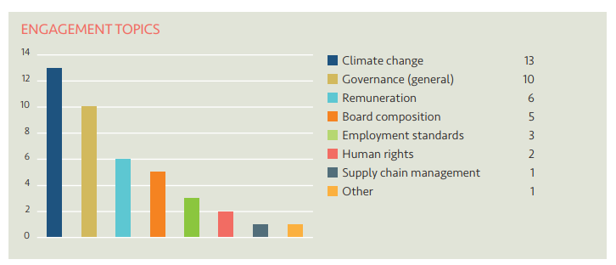

The companies engaged with and the topics raised by LAPFF in Q4 were as follows:

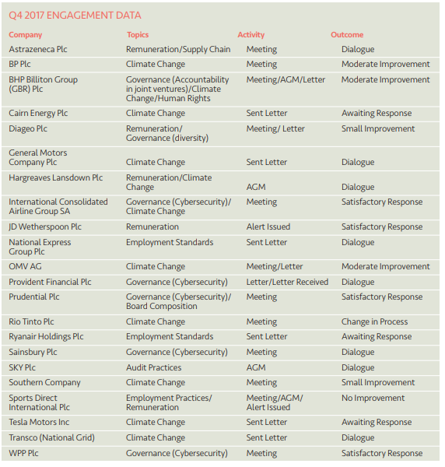
The quarterly statistics show that Climate Change continues to be the issue attracting greatest attention from LAPFF on behalf of member funds.

Climate Action 100+
LPP I has committed to participating in Climate Action 100+. This is a five-year initiative led by investors to engage with the world’s largest corporate greenhouse gas emitters to improve governance on climate change, curb emissions and strengthen climate-related financial disclosures. For the UK and Europe, the initiative is being co-ordinated by the Institutional Investor Group on Climate Change and the PRI and will involve collaborative engagements which bring the resources and concerns of institutional investors together as part of an agreed, organised and common approach.
- Shareholder Litigation

LPP I employ Institutional Protection Services (IPS) as an external provider of litigation monitoring services to ensure shareholder litigation cases affecting securities owned by the GEF are known about, claims are filed in a timely way and progress is monitored and followed up with Claims Administrators. In addition, IPS monitor cases relating to shares held by LCPF in the period before the Fund pooled its listed equity investments from November 2016. Litigation can arise quite some time after shares have been sold and monitoring new cases and referring back to historic holdings records to establish rights of ownership is an ongoing task.
IPS provide LPP I with monitoring information on a quarterly basis detailing the number of cases investigated. The monitoring report provided for Q4 2017 confirmed that whilst 2 potential new cases were identified where the Fund might have an entitlement to join an action, further analysis had ultimately discounted both.

- Active Investing

This section of the RI report is dedicated to updating the Committee on new developments within stewardship and RI and interpreting these within the context of the Fund's responsibilities and interests.

Principles of Responsible Investment (PRI) – 2018 Annual Reporting Round and LGPS Pool Membership

At its last meeting the Committee received the Assessment Report for the Fund’s first set of annual reporting against the PRI Principles. 2017 was the first year in which it was mandatory for LCPF to report as a PRI signatory. Reporting covered the period from 1st January to 31st December 2016. All PRI signatories must participate in a detailed assessment process every year which involves responding to detailed indicators designed to capture overall approach/arrangements and specific efforts/activities over the previous 12 months.

The PRI Reporting Framework for 2018 opened on 4th January 2018. The final deadline for submitting responses online is 3rd April 2018. LPP I will be drafting a comprehensive return for LCPF for the period 1st January to 31st December 2017 which will be reviewed by the Head of Fund ahead of the submission date. A full copy of the submission will be shared with the Committee at its next meeting.

LPP has been advised that the PRI are presently reflecting on the position of LGPS Pools as prospective new signatories to the PRI Principles and are considering options for encouraging their participation. Pools are recognised to have significant potential for materially increasing the value of assets being managed in accordance with the RI principles and for bringing benefits of scale, resourcing and expertise. A practical challenge to be overcome is the implied duplication within reporting if underlying funds and LGPS Pools are both signatories of the PRI simultaneously. This is one of a few issues to be considered and solved by the PRI in agreeing a best approach for accommodating and encouraging signatory status for LGPS pools going forward.

